Intent
We aim to inspire all children to develop a life-long love of physical activity and sport. Through good physical education, whole school values and a whole child approach, we aim to nurture confident, resilient children who will strive to achieve their personal best. We listen to our pupils' wants and integrate their needs within a wide range provision of active experiences including extra-curricular clubs, competitive inter and intra school sporting events and fully-inclusive house competitions every half term to enrich our broad curriculum. We endeavour to aid our children in developing future skills and values, encouraging them to celebrate and modestly respect their own triumphs as well as the successes of others. We aim to ensure that our delivery of physical education insights sporting success within every child, allowing all to master their progression of basic skills and nurture their physical confidence beyond Oak Hill Academy. Through the teaching of a bespoke physical education curriculum, as well as the explicit teaching of being physical and how to look after their own well-being, all children can develop with confidence in their capabilities to be successful against any sporting challenge and sustain an active lifestyle at secondary school and beyond.  We strive to educate both our children and families to develop a greater understanding about how to live healthy lifestyles and make healthy choices. We are dedicated to ensuring healthy minds, as well as bodies, and continually strive to support our children's well-being. We have strong links with local clubs and partnerships within our community to ensure our children and families receive the support, knowledge and opportunities they need. | 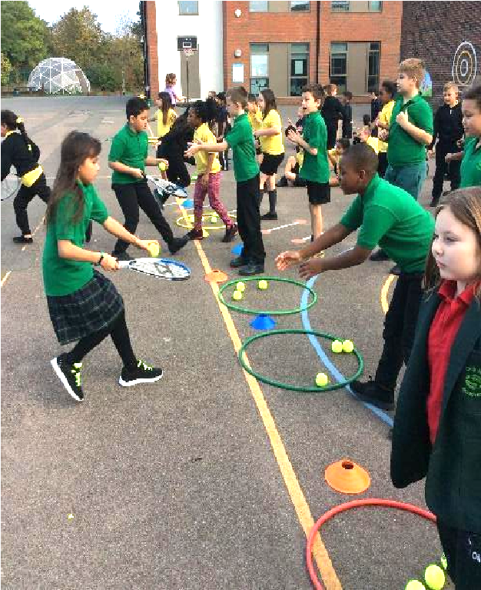
Implementation
At Oak Hill Academy, we strongly believe that we need to provide opportunities for children to increase their understanding of what a healthy and active lifestyle looks like through P.E. . We provide a wide range of fun opportunities for children to get active in class and on the playground. This is delivered through our robust and successful P.E. curriculum, Golden Mile, 5 a day, lunchtime activities, P.E. interventions, extracurricular opportunities and through transicipliary elements of our curriculum. Oak Hill’s successful and popular Healthy Living club encourages the children, and their families, to make healthier lifestyle choices both physically and mentally. Staff receive bespoke PE training and follow the ‘Get Set 4 PE’ scheme across the Key Stage. The scheme, and in house training, gives teachers the subject knowledge, confidence and support in assessment, development and delivery of high quality P.E which leads to high level engagement, challenge and progress for all pupils. P.E. lessons, clubs and targeted intervention groups across the Key Stage provide exciting cross curricular opportunities and, with child wellbeing at the forefront, develop all the children physically, socially and emotionally. Important to Oak Hill Academy is ensuring we offer a wide range of extracurricular clubs for all children to have the opportunity to join and take part in for fun and enjoyment and also to nurture children’s specific skill sets and talents. To further encapsulate a love for PE, regular inter-house competitions for all children allow the children to showcase the skills that they have learnt and develop skills that go beyond the curriculum such as Leadership & Responsibility, Sense of Accomplishment, Confidence to Take Action and Heroes (8 Conditions). | 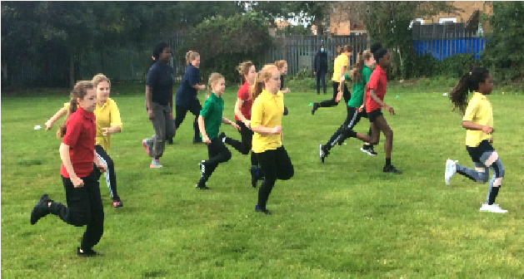
Impact
- Exposure to a wide and exciting range of physical activities helps develop the children’s understanding and control of a wide range of P.E. skills.  - Children are regularly expected to draw on prior learning and skills to develop and progress their learning.  - Regular opportunities for children to be leaders in P.E. develop children’s communication skills and confidence.  - A love of activity, sport and active healthy choices is ignited to allow the children to make positive choices in life beyond Oak Hill.  - Develops the whole child (social, emotional and thinking), not just their sporting ability.  - Provides all children with access to a wide range of physical activities such as:  - Swimming - Athletics - Netball - Yoga - Fitness - Tennis - OAA - Cricket - Rounders  - Opportunities for children to be physically active for a sustained period of time throughout a school day.  - Children have the ability to investigate, analyse, experiment and work expressively to explore their own ideas.  - Development of the Future Skills which promote respect within all areas of their learning.  - Children and their families gain a confident understanding of what a healthy and active lifestyle looks like which will help to support their well-being.  - Daily additions to the P.E. curriculum allows the children to find a love for P.E. and allows them to recognise the benefits from being active.  - Registers of attendance at clubs show a higher percentage of children attending clubs, including vulnerable groups. | 